
Business Model

Meridian Supply Co.
Tamar Tutisani

Contents
Meridian Supply Co. 1
1 Business Background 3
1.1 Business background 3
1.2 Business Questions the Report Answers 3
2 DATA SOURCE AND CONNECTION 4
3 DATA PREPARATION 4
4 DATA MODEL 4
5 DAX: CALCULATED COLUMNS 5
6 DAX: Measures 6
7 REPORT PAGES AND VISUALS 8
7.1 Overview Page 8
7.2 Products & Categories Page 9
7.3 Customers & Markets Page 10
8 INTERACTIVE FEATURES 11

Business Background

Business background
Meridian Supply Co. is a global office, furniture, and technology supplier serving Consumer, Corporate, and Home Office customers across the US (domestic) and EU (international) markets. The company operates two distinct sales channels, domestic (US-based operations) and international (primarily EU-based), both feeding a unified data warehouse for consolidated reporting.
The purpose of this report is to give sales and operations leadership a single place to monitor revenue, profit, and fulfillment performance by category, geography, and customer segment, and to spot which markets and products are over- or under-performing quickly enough to act on it.
End user: Sales Operations Manager and regional Category Managers, non-technical business users who need answers in seconds, not a data model to query.
Logo: The Meridian Supply Co. logo uses an upward staircase of four horizontal bars in increasing height, positioned left-to-right in amber (#ED7D31), symbolizing growth, progress, and expanding inventory. Below the icon sits "MERIDIAN SUPPLY CO." in bold Segoe UI, navy (#1F3864). The staircase reads as both upward momentum and a stylized stack of supply boxes, fitting for a company helping customers climb toward their goals.

Figure 1. Logo: Ascending Staircase Growth Mark
Brand palette: Navy #1F3864 (primary), Gray #595959 (secondary/text), Amber #ED7D31 (accent/highlight). Segoe UI is used throughout for typography.

Business Questions the Report Answers
- Which countries and cities generate the most revenue, and is that shifting?
- Which product categories are growing or shrinking year over year?
- How profitable is each category once discounting is accounted for?
- Which customer segment (Consumer/Corporate/Home Office) and which market (US/EU) drive the business?
- How is order fulfillment (ship mode, priority) distributed, and what does it cost?

DATA SOURCE AND CONNECTION
The report connects to a PostgreSQL data warehouse built specifically for this project, accessing the bl_dm schema, the dimensional layer sitting on top of a 3NF business layer and a staging layer, populated from domestic and international sales source files (CSV format). Data was loaded using Import mode rather than DirectQuery.
For a periodic sales-history load like this one, where near-real-time freshness doesn't matter but modeling flexibility and interactivity do, Import is the right choice. The data warehouse will be refreshed on a scheduled basis (e.g., daily or weekly), ensuring the report stays reasonably current without sacrificing the full feature set and responsiveness that Import provides.

DATA PREPARATION
In Power Query, all tables and columns were renamed from their database-style names (e.g., sales_amt, dim_geography) to business-friendly names (e.g., "Sales Amount", "Geography"), so that every visual, tooltip, and field list inherits a clean label automatically rather than needing to be retitled one visual at a time. Tables below show what got renamed.
Original table | Rename to
fct_sales_dd | Sales
dim_time_day | Date
dim_products | Products
dim_customers_scd | Customers
dim_geography | Geography
dim_employees | Employees
dim_order_attributes | Order Attributes
Table 1. Renamed Tables
Audit columns (insert_dt, update_dt, source_system, source_entity) were removed from all tables, as they carry no reporting value and only clutter the field list.
The Customers table required special handling. Because it stores SCD2 (Slowly Changing Dimension Type 2) history, a customer can appear across multiple rows, one row for each version of their record as attributes changed over time. To allow a clean one-to-many relationship into the fact table, the table was filtered to active records only (is_active = 'Y') and the now-redundant versioning columns (start_dt, end_dt, is_active) were removed. This ensures that customer_surr_id is unique within the filtered table and can serve as a proper relationship key.

DATA MODEL
The star schema centers on a Sales fact table (fct_sales_dd) connected to six dimension tables: Date (dim_time_day), Products (dim_products), Customers (dim_customers_scd), Geography (dim_geography), Employees (dim_employees), and Order Attributes (dim_order_attributes).
Every relationship was manually verified in Manage Relationships rather than assumed from auto-detection.
Although the database enforces a foreign key between the fact and the dimension table, a database-level constraint does not automatically guarantee a Power BI model relationship exists. If that link is missing silently, due to mismatched data types after import, a table added after auto-detect ran, or any other reason, dimension table sits in the model with no relationship at all. When that happens, filtering by any other field has nothing to propagate into dimension table.
To fix this, every relationship was manually verified: If the relationship had been missing, it was recreated manually.
The Customers relationship:
The Customers relationship required manual creation altogether, since SCD2 dimensions intentionally have no database-level foreign key constraint (this is by design, to avoid cascade-delete complications during versioning). The relationship was created as Sales[customer_surr_id]-> Customers[customer_surr_id], Many-to-1, Single direction. This only works cleanly because the table was first filtered to active rows only in Power Query, giving the table a unique key that a relationship requires.
Date table configuration:
The Date table required special handling before being marked as the official Date Table. The default row (with date_id = -1 and date value 1900-01-01) creates a 34-year gap between 1900 and the actual data range (2024–2025), which prevents Power BI from recognizing the table as a valid date table. This default row was filtered out in Power Query (Home > Reduce Rows > Keep Rows, unchecking the -1 row) to create a continuous calendar with no gaps. Once filtered, the Date table was marked as the official Date Table on its "Date" column. This configuration is required for any time-intelligence DAX functions (TOTALYTD, PARALLELPERIOD, etc.) to evaluate correctly. The default rows in other dimension tables (Products, Customers, Geography, etc.) were retained, as they serve an important purpose: handling NULL or missing values in the source data by providing a surrogate key reference point.
Hidden fields:
The following technical surrogate keys and audit fields were hidden from the report view to avoid cluttering the interface for end users, while retaining their ability to drive relationships and sorting: date_id, product_surr_id, geography_surr_id, employee_surr_id, order_attr_surr_id, customer_surr_id, customer_src_id, geography_src_id, product_src_id, employee_src_id, and event_dt.

DAX: CALCULATED COLUMNS
Three calculated columns were added to support sorting and categorization.
Year Month Label (Date table):
Year Month Label = LEFT([Month], 3) & " " & [Year]
Produces readable month labels like "Jan 2024", "Feb 2024", etc., for use on chart axes.
Year Month Sort (Date table):
Year Month Sort = VALUE([Year] & [Month Number])
A numeric column (e.g., 202401 for January 2024, 202402 for February) used to sort Year Month Label chronologically instead of alphabetically. After creating this column, Year Month Label was configured to "Sort by Column: Year Month Sort". Month Number was then hidden from the report view, as it serves only as a sorting helper and is not meant for end-user display.
Discount Band (Sales table):
Discount Band =
SWITCH(
TRUE(),
Sales[Discount Rate] = 0, "No Discount",
Sales[Discount Rate] <= 0.2, "Low (up to 20%)",
Sales[Discount Rate] <= 0.4, "Medium (20–40%)",
"High (40%+)"
)
Segments each transaction's discount rate into readable tiers (No Discount / Low / Medium / High), providing a stable, interpretable way to analyze discounting regardless of how concentrated the raw discount values turn out to be in the actual data.

DAX: Measures
Thirteen measures were created to support the report's visuals and KPIs. All measures use comma-separated number formatting with no unnecessary decimals (currency measures: 0 decimals; percentage measures: 1 decimal) to ensure consistency across every chart and table.
Core aggregations:
Sums all sales amounts across the selected filters.
Total Sales Amount = SUM(Sales[Sales Amount])
Sums all profit amounts.
Total Profit = SUM(Sales[Profit Amount])
Sums all order quantities.
Total Quantity Sold = SUM(Sales[Quantity])
Sums all shipping costs.
Total Shipping Cost = SUM(Sales[Shipping Cost])
Calculates profit as a percentage of sales. The third argument (0) means "return 0 if division by zero occurs" rather than an error.
Profit Margin % = DIVIDE([Total Profit], [Total Sales Amount], 0)
Calculates the mean discount rate across all transactions in the filter context.
Average Discount % = AVERAGE(Sales[Discount Rate])
Returns today's date, displayed as a card KPI at the top of the Overview page.
Today Date = TODAY()
Sales Amount – Latest Date:
This measure always shows the total sales for the most recent date in the dataset, regardless of which date range or other filters are currently applied elsewhere in the report. It uses ALL(Date) to clear any date filter that might be active, finds the absolute maximum date in the data, then recalculates Total Sales Amount for only that one date. This ensures the KPI always reflects the latest available data point.
Sales Amount Latest Date =
VAR LatestDate = CALCULATE(MAX('Date'[Date]), ALL('Date'))
RETURN CALCULATE([Total Sales Amount], 'Date'[Date] = LatestDate)

Top Sales Country =
VAR CountryTable =
ADDCOLUMNS(
VALUES(Geography[Country]),
"@CountrySales", CALCULATE([Total Sales Amount])
)
VAR TopCountry = TOPN(1, CountryTable, [@CountrySales], DESC)
RETURN
MAXX(TopCountry, Geography[Country])
Top Sales Country:
This measure returns the name of the country with the highest total sales. It builds a virtual table of every country with its corresponding total sales, isolates the single highest-sales row using TOPN(1, …, DESC), and reads the country name off that one row using MAXX. MAXX was used deliberately rather than MINX, MAXX returns the maximum (highest-sales country), while MINX would have returned the minimum (lowest-sales country), which is the opposite of what the measure needs.
Top Sales Country =
VAR CountryTable =
ADDCOLUMNS(
VALUES(Geography[Country]),
"@CountrySales", CALCULATE([Total Sales Amount])
)
VAR TopCountry = TOPN(1, CountryTable, [@CountrySales], DESC)
RETURN
MAXX(TopCountry, Geography[Country])
% of Category Total (Month):
This measure calculates each product's share of total sales within its Year-Month and Category combination. The key insight is the use of ALLEXCEPT instead of ALL. The function ALL would clear every filter on the Date and Products tables, including the Year-Month and Category context that the calculation is supposed to respect — destroying the "by month and category" part of the requirement. ALLEXCEPT instead clears everything else on those tables while preserving exactly the two columns named, so the denominator becomes "total sales for this exact Year-Month + Category combination, across all products", and the row's own sales divided by that gives each product's share within its context. This measure is used in a table on the Products & Categories page.
% of Category Total (Month) =
VAR MonthCategoryTotal =
CALCULATE(
[Total Sales Amount],
ALLEXCEPT(Date, 'Date'[Year Month Label]),
ALLEXCEPT(Products, Products[Category])
)
RETURN DIVIDE([Total Sales Amount], MonthCategoryTotal)
Current Year Sales & Prior Year Sales:
These measures feed the bullet chart on the Products & Categories page, showing whether each category is outperforming its own prior-year result. Both are anchored to the latest year actually present in the data (via MAX(Date[Year])) rather than to TODAY(), since the report's calendar only covers 2024–2025.
Current Year Sales =
VAR LatestYear = CALCULATE(MAX('Date'[Year]), ALL(Date))
RETURN CALCULATE([Total Sales Amount], 'Date'[Year] = LatestYear)

Prior Year Sales =
VAR LatestYear = CALCULATE(MAX('Date'[Year]), ALL('Date'))
VAR PriorYear = FORMAT(VALUE(LatestYear) - 1, "0")
RETURN CALCULATE([Total Sales Amount], 'Date'[Year] = PriorYear)
Drillthrough Country
Drillthrough Country = SELECTEDVALUE(Geography[Country], "All Countries")
Displays the currently selected country on the Country Details drillthrough page. When a user drills through from the map on the Overview page by right-clicking a country, this measure returns the name of that country.
Sales Trend Title:
This measure powers the dynamic chart title on the Overview page's line chart. It returns a string like "Sales Trend – Office Supplies" when a single category is selected, or "Sales Trend – All Categories" when no category filter is active or multiple categories are selected.
Sales Trend Title = "Sales Trend – " & SELECTEDVALUE(Products[Category], "All Categories")

REPORT PAGES AND VISUALS
The report consists of three visible pages (Overview, Products & Categories, Customers & Markets) plus two hidden pages supporting drillthrough and custom tooltips. All visible pages share a consistent header band containing the logo (top-left), page title (top-center), and a three-button page navigator (top-right). All pages use a 16:9 (1600×900) canvas size and share a unified slicer rail on the left side (Year, Category, Segment, Market) configured to sync across pages, a filter picked on Page 1 automatically persists when navigating to Page 2 or Page 3.

Overview Page
The Overview page leads with a headline KPI row pinned at the very top of the content area, containing six cards aligned to equal height (100px) and width (244px): Today, Top Sales Country, Latest Day Sales, Total Sales Amount, Total Profit, and Total Quantity Sold. This placement ensures the most critical numbers are visible without scrolling or interacting.
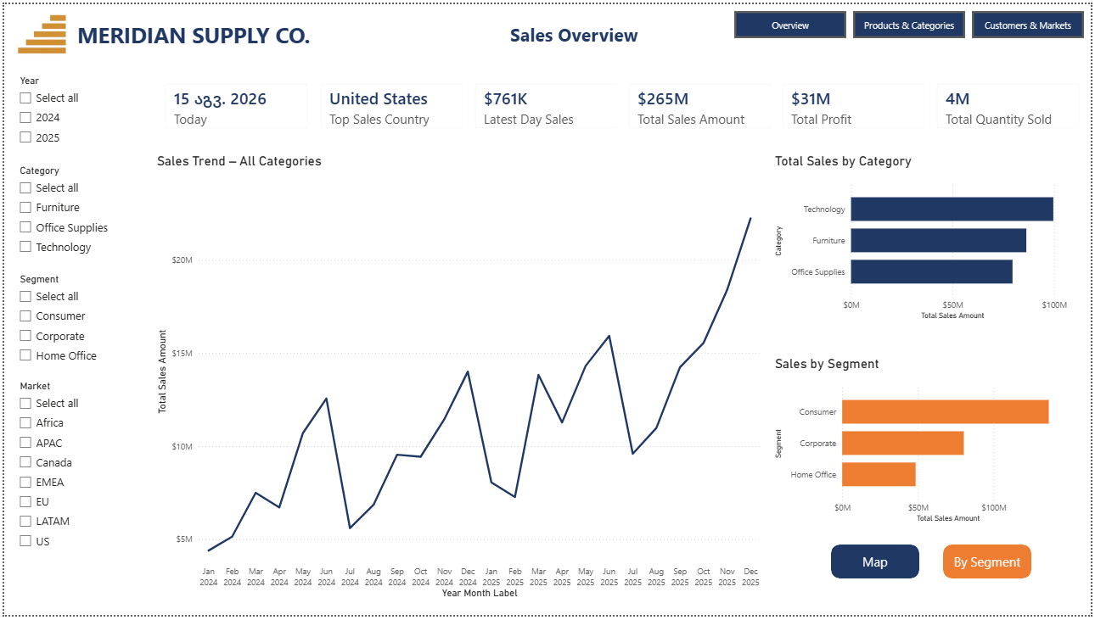
Figure 2. Overview Page
Below the KPIs, the page contains four primary visuals:
- Line chart (Sales by Month): X-axis = Year Month Label (sorted chronologically via the Year Month Sort column), Y-axis = Total Sales Amount. The chart title is bound to the Sales Trend Title measure, so it updates dynamically based on the currently selected product category (e.g., "Sales Trend – Furniture" if Furniture is selected, or "Sales Trend – All Categories" if no category filter is active). The chart displays the full 2024–2025 sales trajectory across all months.
- Bar chart (Total Sales by Category): Displays Total Sales Amount broken down by Product Category (Furniture, Office Supplies, Technology), offering a quick visual of which categories are driving revenue.
- Map (Filled Map): Location = Country, Size/Color = Total Sales Amount. Selecting a country anywhere in the report correctly filters this map — only the selected country's territory displays in color while others fade.
- Bookmark toggle (Map vs. Segment Breakdown): A second visual, a bar chart showing Total Sales Amount by Segment (Consumer, Corporate, Home Office), is positioned directly on top of the map. Using the Selections pane (View > Selections), two bookmarks were created: "View: Map" (map visible, segment chart hidden) and "View: Segment" (opposite). Two buttons labeled "Map" and "By Segment" are positioned above these visuals; each button's action is set to activate its corresponding bookmark, allowing users to toggle between views without leaving the page.
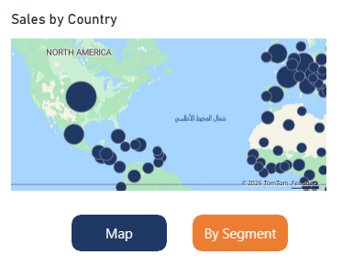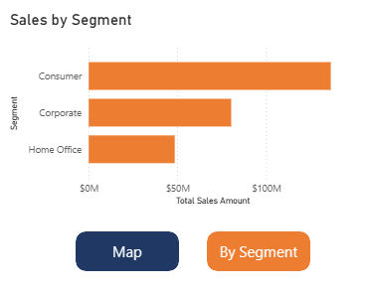

Products & Categories Page
- Matrix (Category Performance): Rows = Category, Values = Total Sales Amount, Total Profit, Profit Margin %. The Profit Margin % column is formatted with conditional color scaling (red for low margins, amber for medium, green for high margins) via Conditional Formatting, making it immediately clear which categories are highly profitable and which are underperforming.
- Gauge chart (Current Year vs Prior Year Sales): Displays Current Year Sales as the value (needle) against Prior Year Sales as the target range. This chart directly answers "Is our total sales outperforming last year?", which is a fundamental business question that drives strategic decisions.
- Bar chart (Sales by Discount Band): Shows Total Sales Amount broken down by Discount Band (the calculated column): No Discount, Low 0–20%, Medium 20–40%, High 40%+), offering a stable, interpretable view of discounting patterns. The "n.a." values (representing null/missing segment data in the source) were filtered out for a cleaner visual.
- Card (Average Discount %): Displays the average discount percentage across all orders, positioned near the Discount Band chart for context.
- Table (Top 10 Products by Sales): Rows = Year Month Label, Category, Product Name; Values = Total Sales Amount, % of Category Total (Month). The table is sorted descending by Total Sales Amount, showing the highest-revenue products first. This table lets users see which specific products are driving sales within each month and category, with the percentage column providing context on each product's share of its category's monthly total.
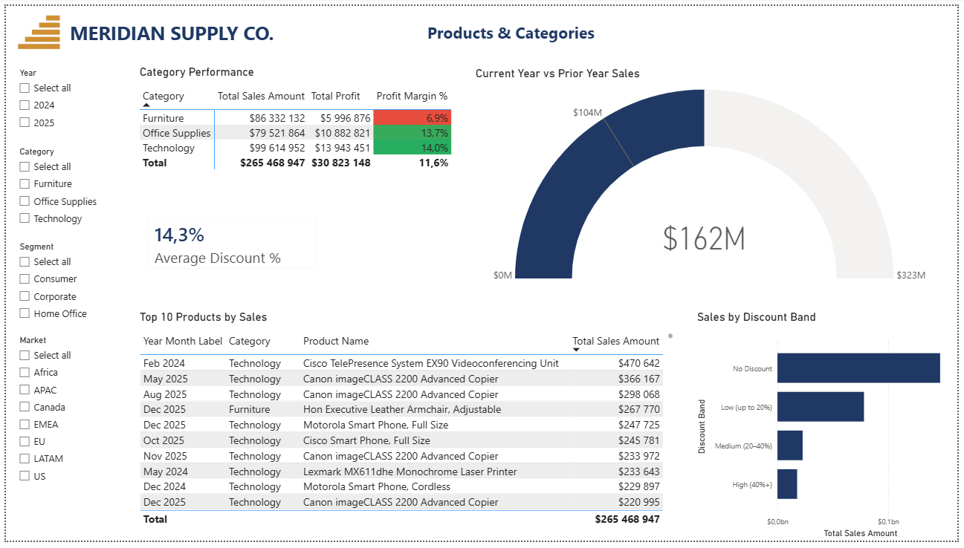
Figure 3. Products & Categories Page

Customers & Markets Page
- Matrix (Segment Performance): Rows = Segment (Consumer, Corporate, Home Office), Values = Total Sales Amount, Total Profit, Total Shipping Cost. This gives operations leadership a quick view of segment profitability and fulfillment costs, showing that Consumer is the highest-revenue segment while Corporate drives significant profit.
- Bar chart (Sales by Ship Mode): Displays Total Sales Amount broken down by Ship Mode (Standard Class, Second Class, First Class, Same Day). The "n.a." bar (representing international orders, which do not carry Ship Mode data in the source system) was filtered out in the visual's filter pane. This chart helps fulfillment teams understand which shipping modes handle the volume and cost implications.
- Python Pareto Chart (Revenue by Product 80/20 Analysis): A custom Python visual using matplotlib displays the top 15 products by Total Sales Amount as navy bars, with an orange cumulative percentage line overlaid. A teal dashed reference line at 80% illustrates the Pareto principle: approximately 80% of revenue is generated by roughly 20% of products. This visualization immediately reveals which products concentrate the business's revenue and directly informs inventory and marketing prioritization.
- Table (Customers by Sales Ranking): Rows = Customer Name, Segment; Values = Total Sales Amount. The table is sorted descending by Total Sales Amount, identifying the company's top revenue generators by customer and segment, enabling account management teams to allocate resources strategically.

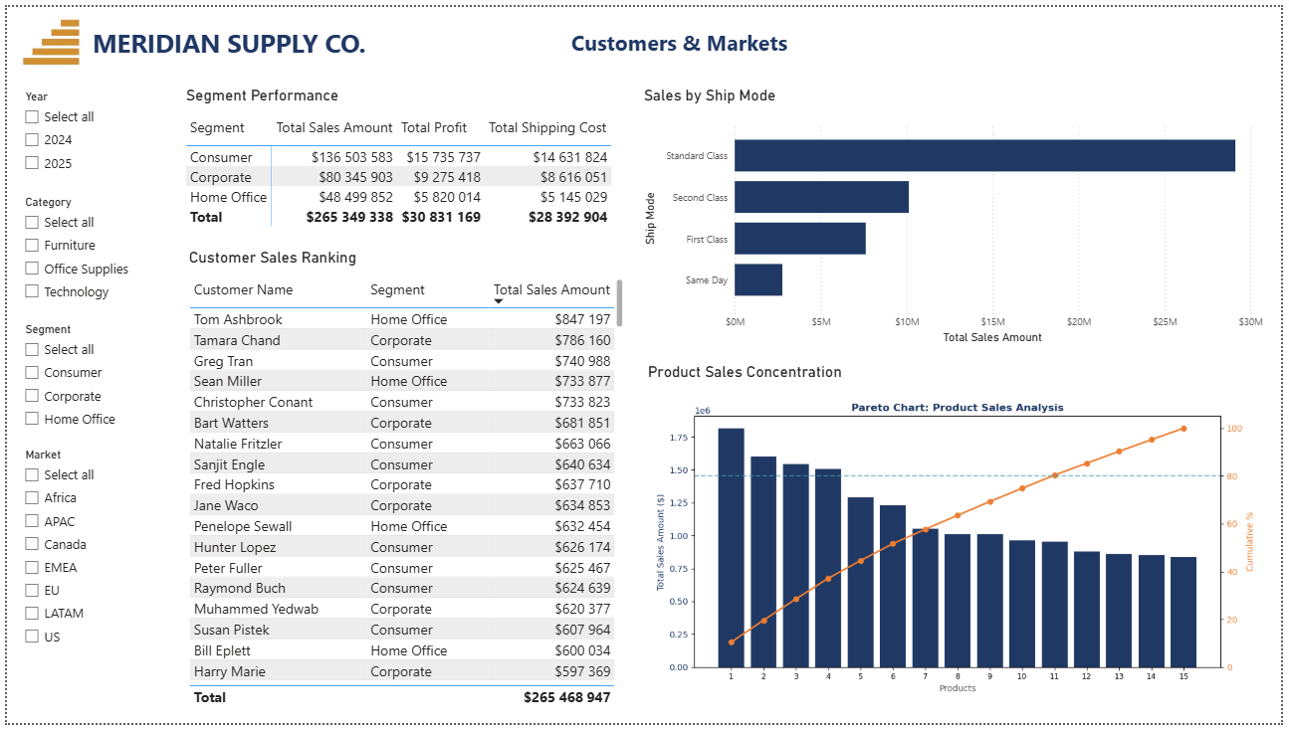
Figure 4. Customers & Markets Page
Python Pareto Chart (Revenue by Product 80/20 Analysis)
The Pareto chart on the Customers & Markets page is a custom Python visual using matplotlib, designed to surface a critical business insight: approximately 80% of revenue is generated by approximately 20% of products (the Pareto principle). This visualization immediately reveals which products concentrate the business's revenue and directly informs inventory management, marketing prioritization, and product portfolio decisions.
Visual Design:
The chart displays the top 15 products by Total Sales Amount as navy bars (#1F3864) in descending order, with an orange cumulative percentage line (#ED7D31) overlaid on a secondary axis. A teal dashed reference line (#429CAB) marks the 80% threshold, making the principle visually obvious. The chart answers the critical question: "Which products drive the majority of our revenue?"
Technical Implementation:
The visual was built by inserting a Python visual. The underlying Python code uses matplotlib to plot bars (Total Sales Amount by Product Name) and a cumulative percentage line, with alpha opacity set to 1.0 for full color saturation matching the brand palette. The chart is positioned on Page 3 (Customers & Markets) at coordinates X=795px, Y=290px with dimensions 575×190px, filling the white space while maintaining visual hierarchy.
Business Impact:
This visualization transforms raw product sales data into an actionable insight: focusing inventory, marketing spend, and fulfillment resources on the top 20% of products can capture 80% of revenue, dramatically improving operational efficiency and ROI.
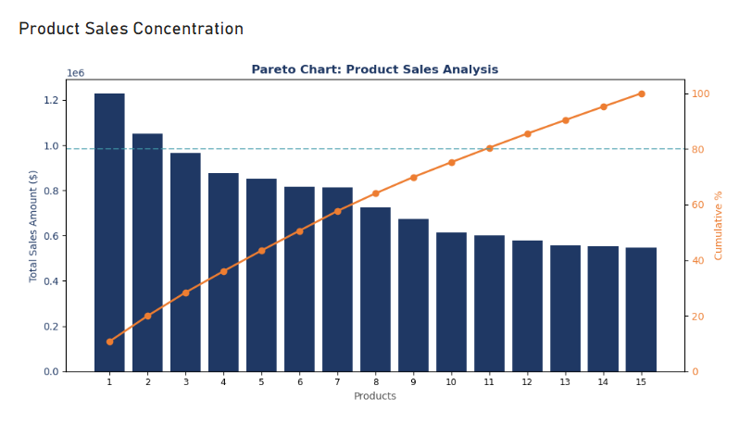
Figure 5. Custom Pareto Chart created via Python
Uniform Sizing and Spacing
All charts of the same type (all bar charts, all line charts, all matrices) were sized identically or proportionally across pages, widths and heights were set in the Format pane's General tab and maintained for consistency. A consistent gap was maintained between all visuals using gridlines and snap-to-grid, keeping the report visually calm rather than cluttered. All visuals use the brand color palette (Navy #1F3864, Amber #ED7D31, Teal #429CAB, Gray #595959) consistently across all pages.

INTERACTIVE FEATURES
Page Navigation:
A three-button page navigator (inserted via Insert > Button > Blank button with action type set to Page Navigation.) provides one-click movement between the three visible pages. Each button is configured to navigate to its corresponding page. The buttons were positioned in the top-right corner of Page 1 and then copied to Pages 2 and 3 to maintain consistent placement and functionality across all visible pages, allowing users to move between pages with a single click. The navigator automatically skips hidden pages.
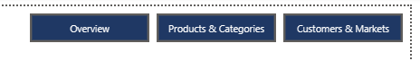
Figure 6. Page Navigation
Bookmark Toggle (Overview page):
On the Overview page, a bookmark-driven toggle switches the same canvas area between the country map and a segment breakdown chart (Sales by Segment). This was built using the Selections pane (View > Selections) to control visual visibility per bookmark. Two bookmarks were created, "View: Map" (map visible, segment chart hidden) and "View: Segment" (opposite), and two buttons labeled "Map" and "By Segment" were positioned above the visuals with bookmark actions assigned to each. This pattern allows users to focus on one analytical lens (geographic or segment-based) at a time without sacrificing screen real estate.
Dynamic Chart Titles:
The line chart on the Overview page (Sales Trend) has its title bound to the Sales Trend Title measure, which updates automatically to reflect the currently selected product category. For example, if Furniture is selected via the Category slicer, the title reads "Sales Trend – Furniture"; if no filter is applied, it reads "Sales Trend – All Categories". This gives users visual confirmation of the filtering context without requiring a separate explanation.
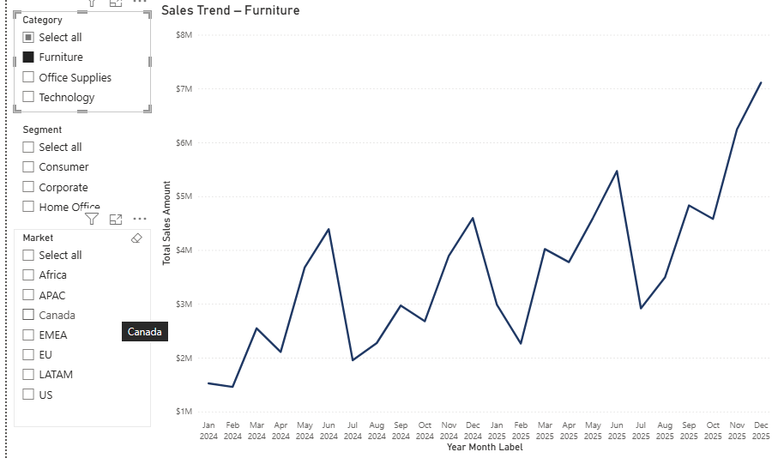
Figure 7. Dynamic Chart Title
Drillthrough (Country Details):
A hidden page called "Country Details" was created as a drillthrough target. The page is configured as a drillthrough page with Geography[Country] added to the Drillthrough filters well. The page contains a back button (auto-added by Power BI), two KPI cards displaying Total Sales Amount and Total Profit filtered to the selected country, a table of top products sold in that country (sorted descending by sales), and a table of top customers in that country (sorted descending by sales). At the top of the page, a filter indicator displays the currently selected country via a Card visual bound to the Drillthrough Country measure (defined as SELECTEDVALUE(Geography[Country], "All Countries")), which dynamically updates to show users exactly which country they're viewing. To use it: navigate to the Overview page, click the "Map" button to display the country map, right-click any country > Drillthrough > Country Details. The page automatically filters to show only data for the selected country, and users can click the back button to return to the Overview page.
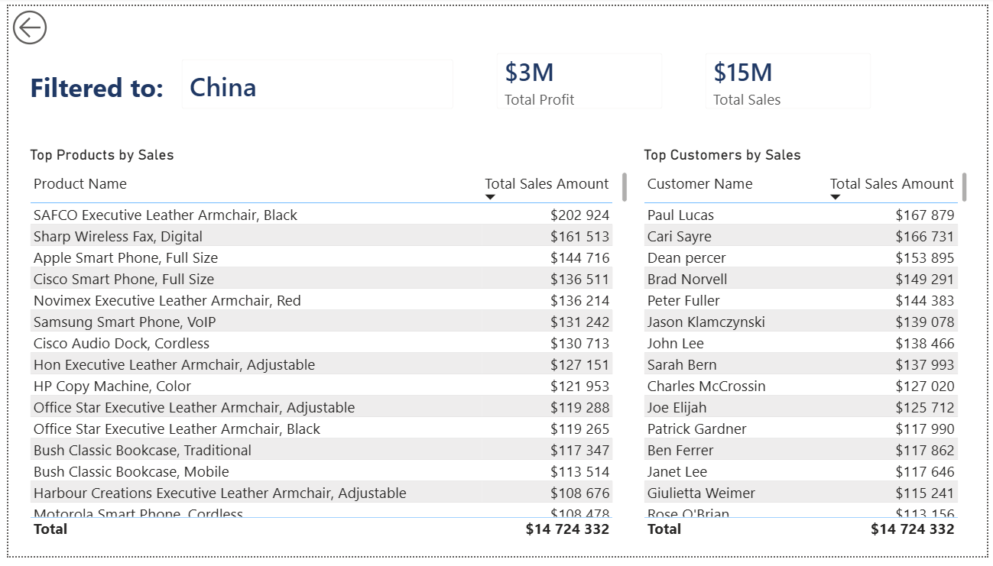
Figure 8. Drillthrough
Custom Tooltip (Category Tooltip):
A hidden page called "Category Tooltip" was created with canvas size set to Tooltip (Format pane > Page Information > Canvas size dropdown) and "Allow use as tooltip" enabled. The page displays a small bar chart of Total Sales Amount by Subcategory and a Profit Margin % card. This page is applied as a custom tooltip to the category matrix on the Products & Categories page (Format pane > Tooltips > Report page > Category Tooltip). When users hover over any category column in the matrix, this mini report appears instead of the default single-value tooltip, providing instant context on subcategory performance within that category.

publishing
The finished Power BI Desktop file (PowerBI_Final_Project_Tutisani.pbix) was published to the Power BI Service via Home > Publish. Once published, the report became accessible via a permanent URL in Power BI Service, this same URL is shared with stakeholders and can be opened in a browser without requiring Power BI Desktop.
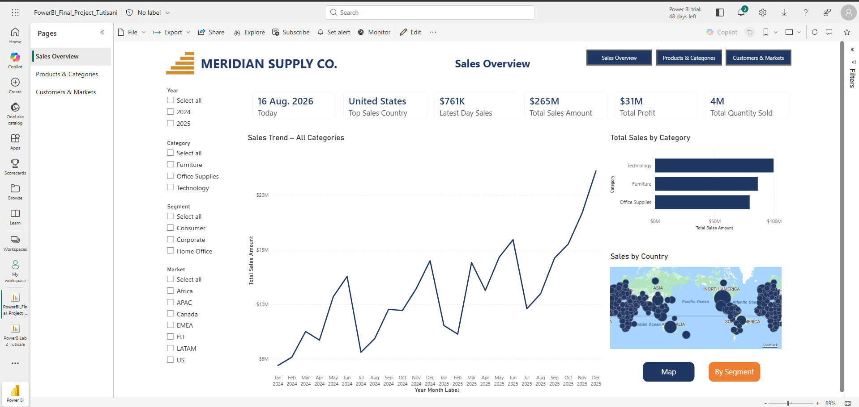
Figure 9. Published report

Conclusion
This Meridian Supply Co. sales analytics report delivers a complete, interactive solution for sales and operations leadership to analyze revenue, profit, and fulfillment performance in seconds. The three visible pages, Overview, Products & Categories, and Customers & Markets, each provide distinct analytical insights through optimized visuals, synced slicers, and interactive features including page navigation, bookmarks, drillthrough, and custom tooltips. A Python Pareto chart reveals the 80/20 principle in product concentration, while conditional formatting and dynamic titles guide users to actionable insights without requiring technical knowledge.
The report is published in Power BI Service and accessible through this link:
https://app.powerbi.com/groups/me/reports/dc7e9509-f38a-4bc2-aa01-700867a93b7b/e81ccec432ca1682d04c?experience=power-bi

